Network with 5 inputs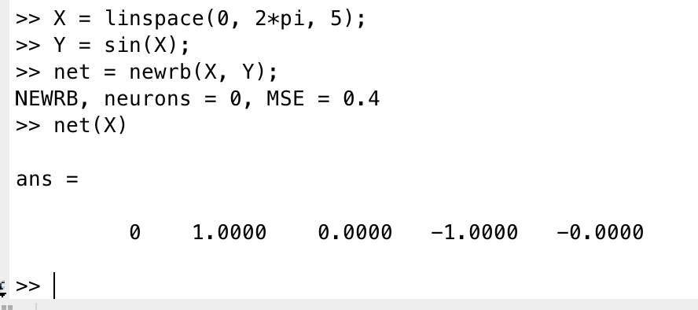

Network with 6 inputs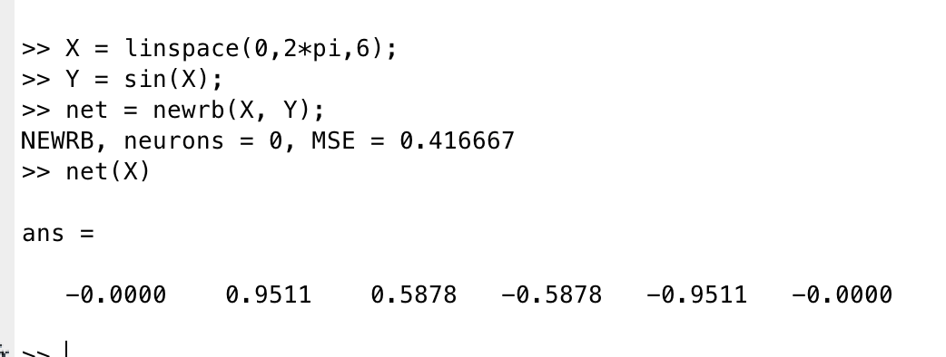

The following is from Matlab website.

<https://www.mathworks.com/help/nnet/ref/newrb.html>

This segment is from the source code of 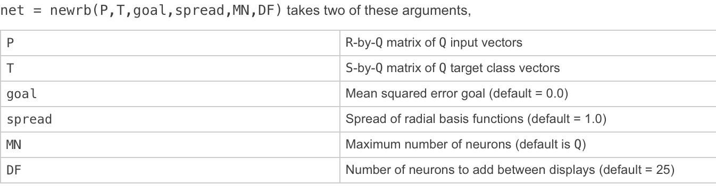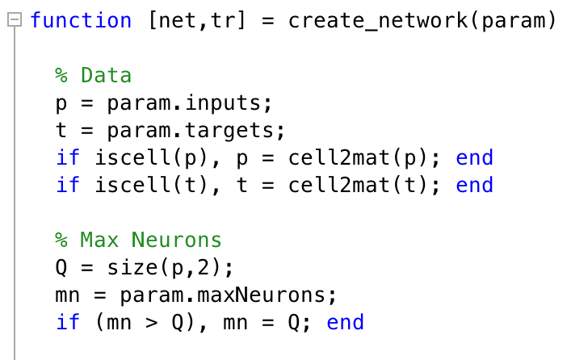newrb